Mini JavaScript Project: Random Password Generator

In this Mini JavaScript Project, I have used some basic HTML5 for designing the structure of my project which was a “Random Password Generator” and CSS3 for giving it a unique glass edge blur effect style. Whilst this project defines the use of JavaScript hence, I have used JavaScript for this “Random Password Generator” to function and generate random passwords when the button “Generate Password” is clicked upon.
I have also used a ‘zoom out’ animation, transition & transform while hovering the button “Generate Password”.
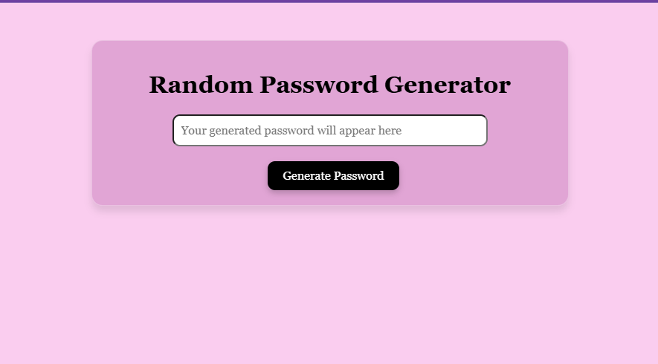
Snapshot Of the Project

Link Of GitHub Repository:
https://github.com/samiabintesajid-ss/MyProjects.git

